# 21BDS0340

# Abhinav Dinesh Srivatsa

# Electronics Lab

# Task 4

# Exercise No.: 1 Date: 16/04/22

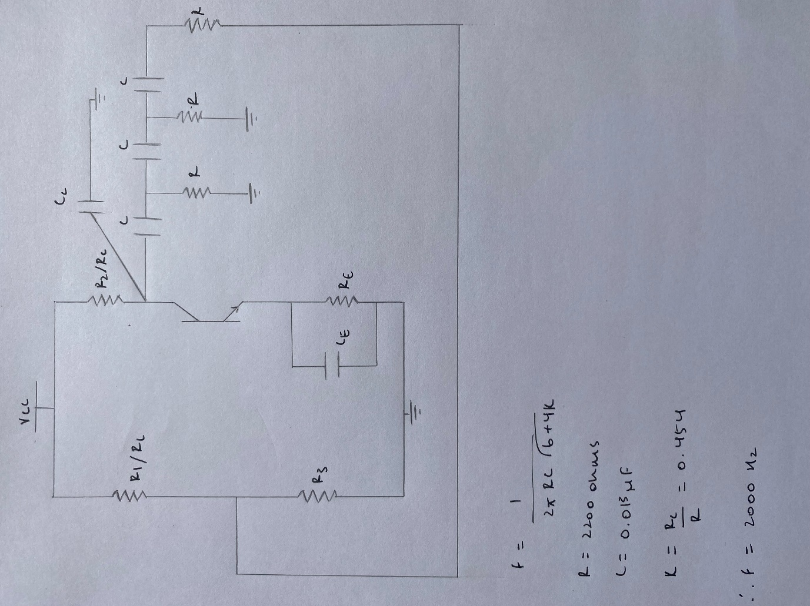RC Phase Shift Oscillator

**Circuit Diagram**

**Components Required**

Basic – Resistors, Capacitors

Sources – VCC, Ground, AC_Voltage

Transistors – BC547BP

Simulate – Instruments – Oscilloscope

**Simulated Circuit Diagram**

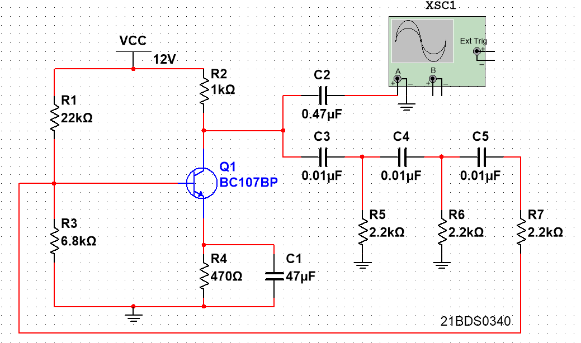

**Simulated Output**

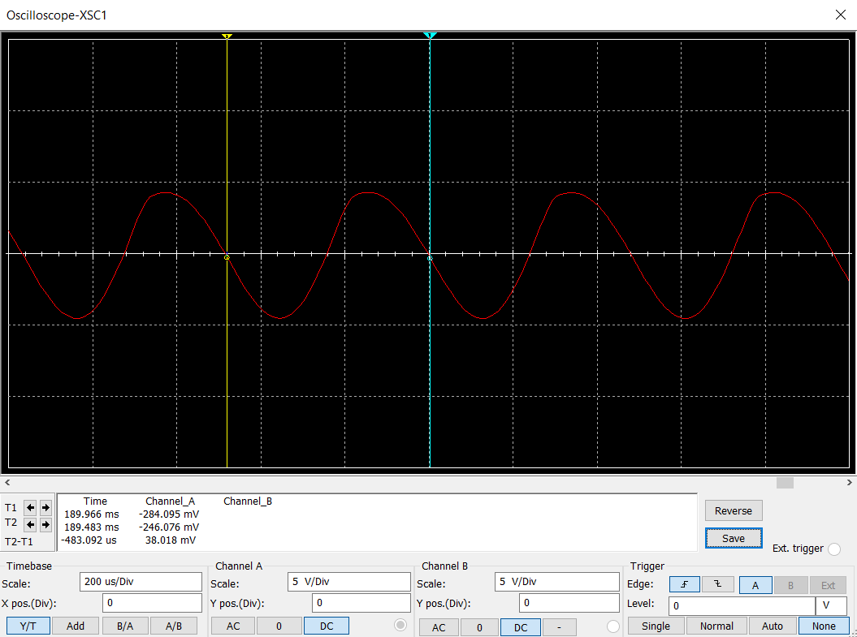

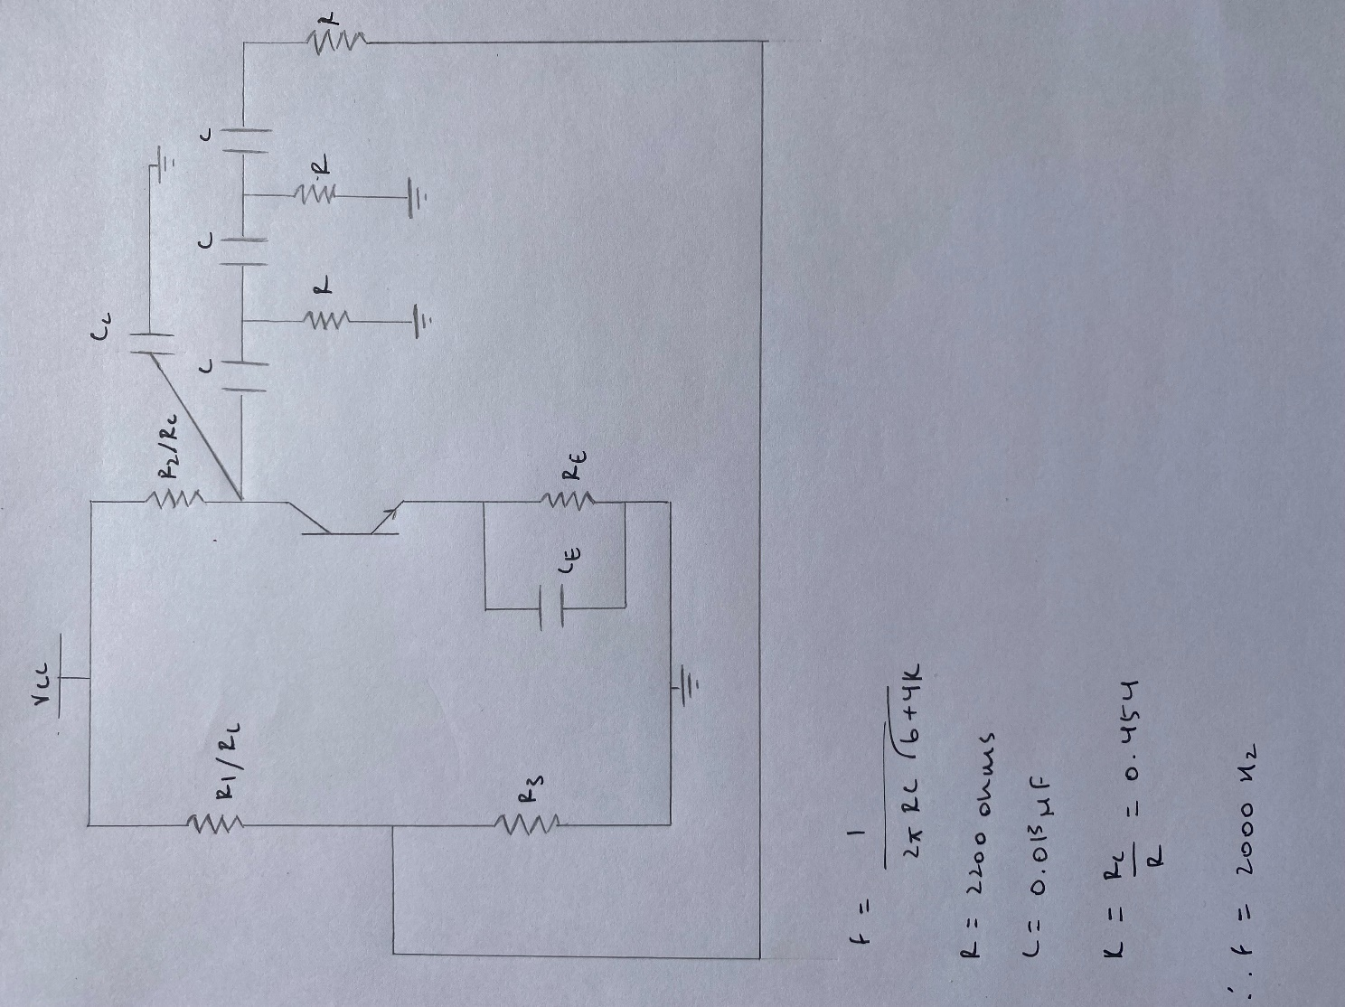**Calculations from Simulated Graph**

**Verification Message**

# Exercise No.: 2 Date: 19/05/22

Logic Gates

**Truth Table**

**Components Required**

Basic – Switch – SPDT

Sources – Power Sources – VCC, Ground

TTL – 7408N, 7401N, 7432N

**Simulated Circuit Diagram 1**

**Simulated Circuit Diagram 2**

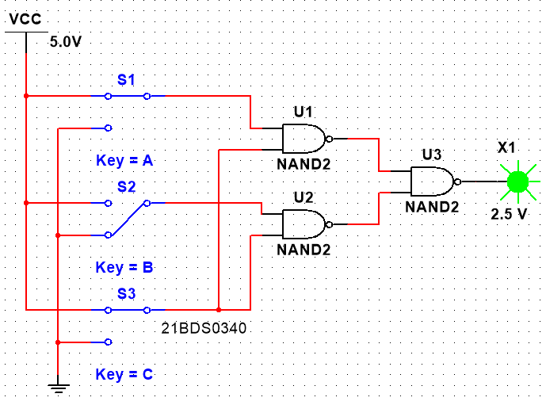

**Simulated Circuit Diagram 3**

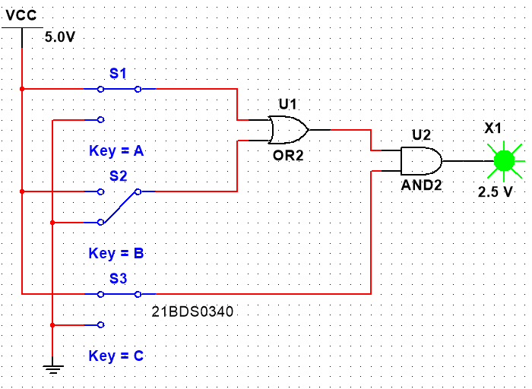

**Simulated Circuit Diagram 4**

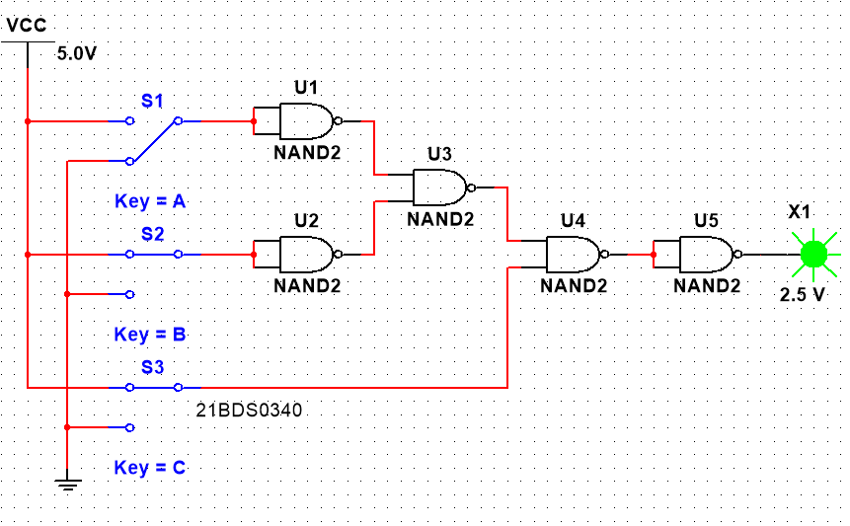

**Verification Message**

